 

**COLLEGE CODE : 9222**

**COLLEGE NAME : THENI KAMMAVAR SANGAM COLLEGE OF**

**TECHNOLOGY**

**DEPARTMENT : B.TECH(IT)**

**STUDENT NM-ID : FEEFB73EB0DDFF6AEB749DEF14E540EA**

**ROLL NO : 922223205043**

**DATE : 19/09/2025**

**Completed The Project Named As**

**PHASE 5**

**NAME : IBM-NJ-STUDENT GRADING SYSTEM**

**SUBMITTED BY,**

**NAME : SARAN S**

**MOBILE NO : 6385375606**

# Project Demonstration & Documentation

**Title:Student Greading System**

1. Final Demo Walkthrough

* **A complete walkthrough of the Student Grading System.**
* **Show all key features: student registration, grade entry, grade calculation, report generation, etc.**
* **Include a live demonstration or a video recording link (if applicable).**
* **Mention technologies used (e.g., frontend, backend, database).**
* **Highlight user roles (Admin, Teacher, Student)**

2. Project Report

* **Introduction: Brief overview of the project and its purpose.**
* **Objective: What the system aims to solve (automated grading, result management, etc.).**
* **Technology Stack: Tools and frameworks used (e.g., React, Node.js, MySQL).**
* **System Architecture: High-level design or architecture diagram.**
* **Features: List and explanation of all major features.**
* **Conclusion: Summary of outcomes and future improvements.**

Program

**<!DOCTYPE html>**

**<html lang="en">**

**<head>**

**<meta charset="UTF-8">**

**<title>Student Grading System</title>**

**<style>**

**body {**

**background-image:url("https://media.istockphoto.com/id/172413295/photo/an-up-close-picture-of-report-card-grades.jpg?s=612x612&w=0&k=20&c=d95S74oUPLZA98yn6QKG0-6OEbgAqgroKzQWH5GxwKA=");**

**background-size: cover;**

**font-family: Arial, sans-serif;**

**padding: 20px;**

**background-color: #f2f2f2;**

**align-items: center;**

**justify-content: center;**

**}**

**.container {**

**background-color: #fff;**

**padding:50px;**

**border-radius: 10px;**

**max-width: 500px;**

**margin: auto;**

**box-shadow: 0 0 10px rgba(0, 0, 0, 0.1);**

**}**

**h2 {**

**text-align: center;**

**color: #333;**

**}**

**label {**

**display: block;**

**margin: 10px 0 5px;**

**}**

**input {**

**width: 100%;**

**padding: 8px;**

**margin-bottom: 15px;**

**border: 1px solid #ccc;**

**border-radius: 5px;**

**}**

**button {**

**width: 100%;**

**padding: 10px;**

**background-color: #4CAF50;**

**color: white;**

**border: none;**

**border-radius: 5px;**

**cursor: pointer;**

**}**

**button:hover {**

**background-color:green;**

**}**

**.result {**

**margin-top: 20px;**

**font-weight: normal;**

**}**

**</style>**

**</head>**

**<body>**

**<div class="container">**

**<h2>Student Grading System</h2>**

**<label for="name">Student Name:</label>**

**<input type="text" id="name" placeholder="Enter student name">**

**<label for="subject1">Subject 1 Marks:</label>**

**<input type="number" id="subject1" placeholder="Enter marks out of 100">**

**<label for="subject2">Subject 2 Marks:</label>**

**<input type="number" id="subject2" placeholder="Enter marks out of 100">**

**<label for="subject3">Subject 3 Marks:</label>**

**<input type="number" id="subject3" placeholder="Enter marks out of 100">**

**<label for="subject4">Subject 4 Marks:</label>**

**<input type="number" id="subject4" placeholder="Enter marks out of 100">**

**<label for="subject5">Subject 5 Marks:</label>**

**<input type="number" id="subject5" placeholder="Enter marks out of 100">**

**<button onclick="calculateGrade()">Calculate Grade</button>**

**<div class="result" id="result"></div>**

**</div>**

**<script>**

**function calculateGrade() {**

**const name = document.getElementById('name').value.trim();**

**const subjects = [**

**parseFloat(document.getElementById('subject1').value),**

**parseFloat(document.getElementById('subject2').value),**

**parseFloat(document.getElementById('subject3').value),**

**parseFloat(document.getElementById('subject4').value),**

**parseFloat(document.getElementById('subject5').value)**

**];**

**const resultDiv = document.getElementById('result');**

**// Validation**

**if (!name || subjects.some(mark => isNaN(mark) || mark < 0 || mark > 100)) {**

**resultDiv.innerHTML = "⚠️ Please enter a valid name and marks (0-100) for all subjects.";**

**resultDiv.style.color = 'red';**

**return;**

**}**

**const total = subjects.reduce((sum, mark) => sum + mark, 0);**

**const average = total / subjects.length;**

**let grade;**

**if (average >= 90) grade = 'A+';**

**else if (average >= 80) grade = 'A';**

**else if (average >= 70) grade = 'B';**

**else if (average >= 60) grade = 'C';**

**else if (average >= 50) grade = 'D';**

**else grade = 'F';**

**resultDiv.style.color = 'black';**

**resultDiv.innerHTML = `**

**<strong>${name}</strong><br>**

**Total Marks: ${total} / 500<br>**

**Average: ${average.toFixed(2)}<br>**

**Grade: <strong>${grade}</strong>**

**`;**

**}**

**</script>**

**</body>**

**</html>**

3. Screenshots / API Documentation

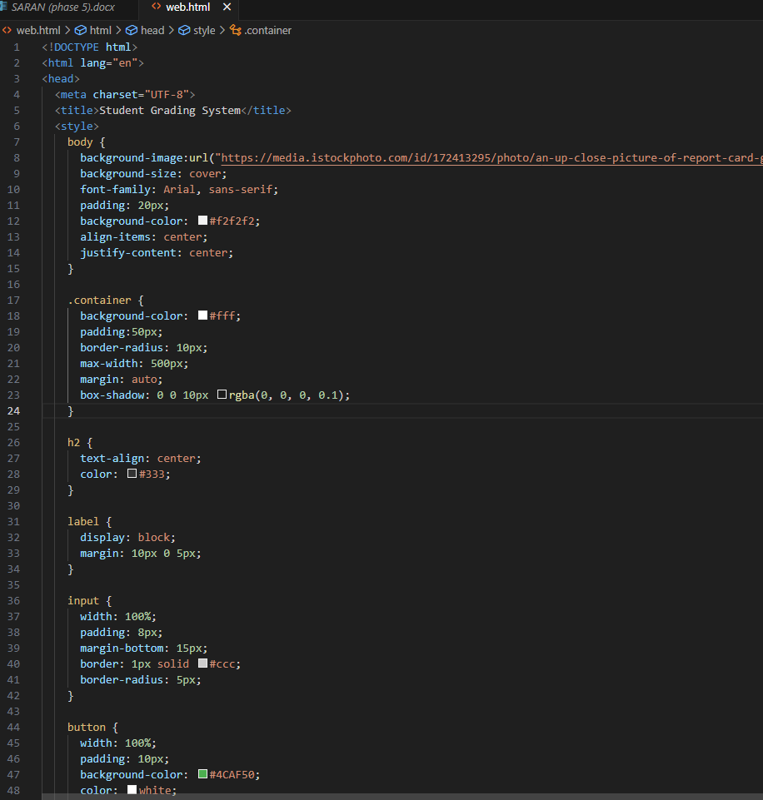

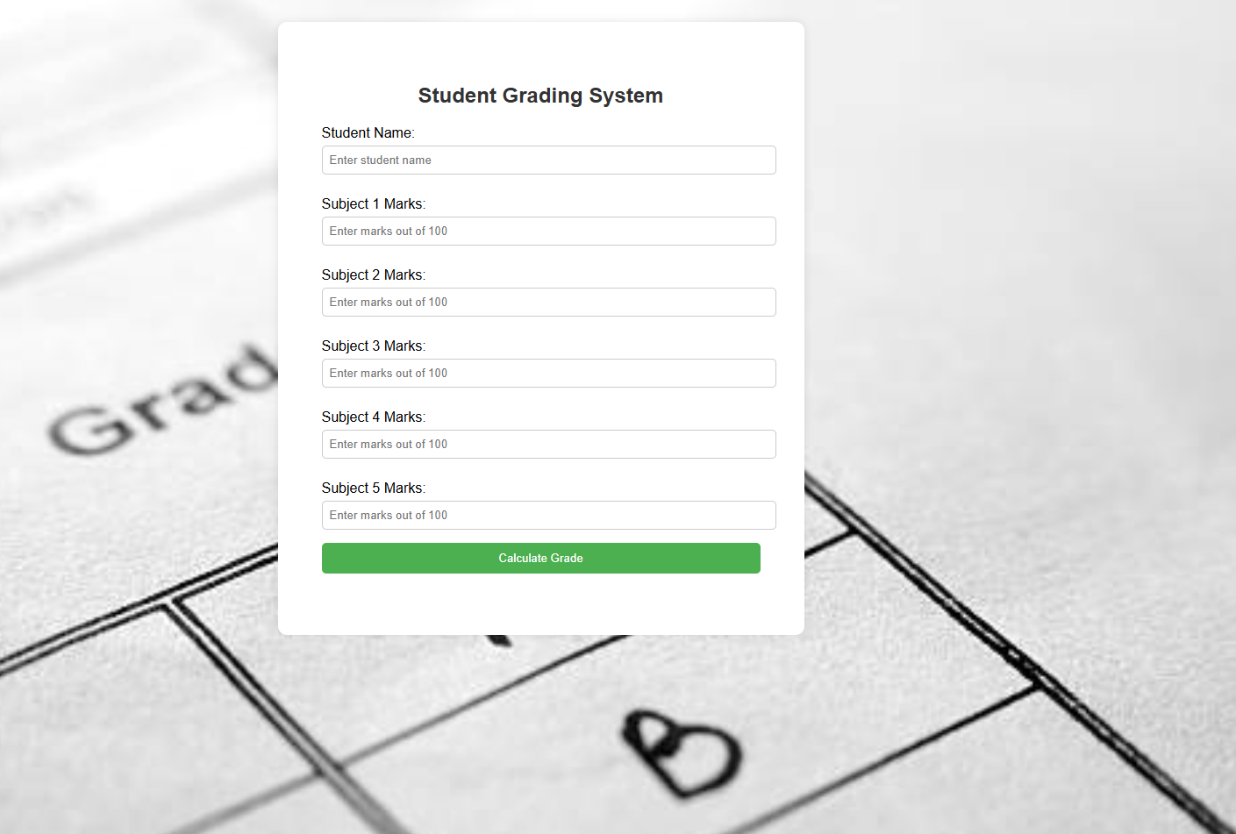

4. Challenges & Solutions

* **Challenge 1: Handling dynamic grading scales  
  Solution: Created a flexible grading logic with configurable rules.**
* **Challenge 2: Securing student data  
  Solution: Implemented JWT authentication and hashed passwords.**
* **Challenge 3: Deploying with database connectivity  
  Solution: Used environment variables and cloud database (e.g., MongoDB Atlas / Firebase / Railway).**

5. GitHub README